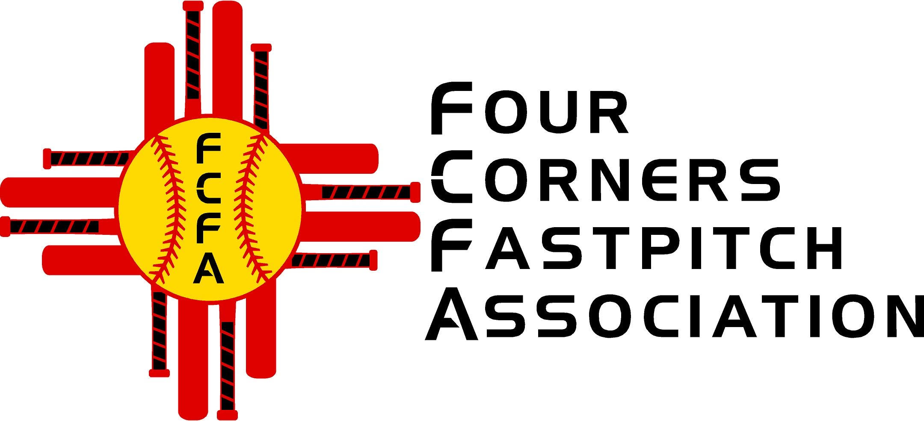

Four Corners Fastpitch Association

PO Box 3024

Farmington, NM 87499

Four Corners Fastpitch Association (FCFA) provides scholarships and equipment to many local youths in the Four Corners area annually at no cost to families in need.

Your company’s sponsorship would be a great contribution to the community youth that participate in the FCFA. Thank you in advance for your contribution.

Please make checks payable to Four Corners Fastpitch Association with “General Operating” in the memo line.

If you would like for us to send you an invoice, please email [usssafcfa@gmail.com](mailto:usssafcfa@gmail.com) and provide the email address to send the invoice to along with the amount of donation.

If you would like to have your company logo listed on our website, please email your logo to usssafcfa@gmail.com.

Thank you!

FCFA

Tax Exempt Organization Number: 501 (c) (3) 27-2193324

For questions or further information please email usssafcfa@gmail.com