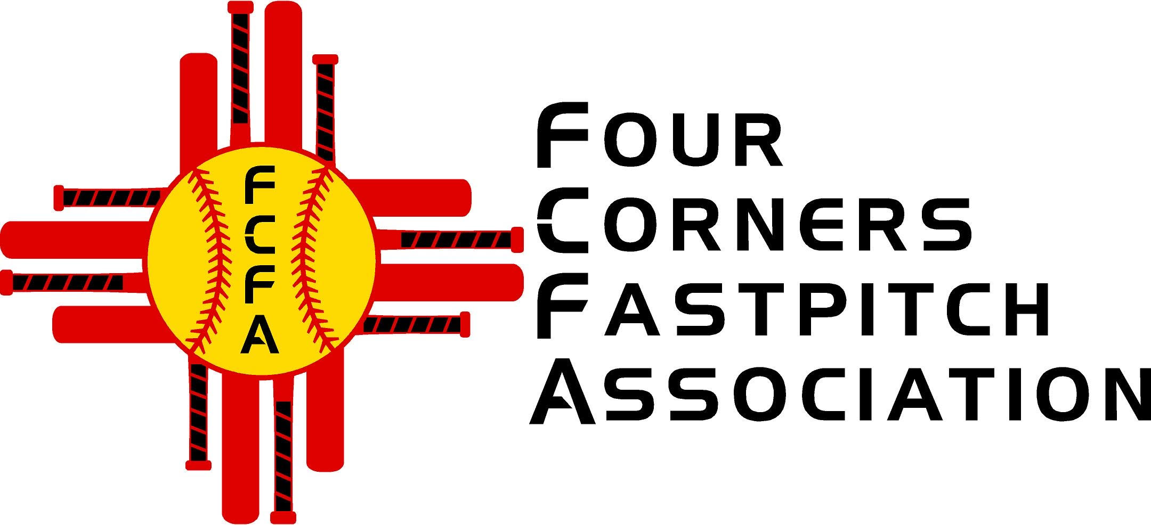

Four Corners Fastpitch Association

PO Box 3024

Farmington, NM 87499

Four Corners Fastpitch Association (FCFA) hosts several tournaments annually that draws hundreds of athletes from all over New Mexico, Texas, Colorado, Arizona and Utah.

The average boost to the area economy can be as much as 500K or more! In 2023 we hosted two tournaments that had 30+ visiting teams for each event and averaged 400 youth visitors per tournament to our area. The tournaments themselves bring people out into the community who visit many restaurants, shops, and area activities!

The largest expense to the tournament is the cost of Umpires, Awards/Trophies, and City of Farmington facilities.

Your company’s sponsorship would be a great contribution to not only the youth but the community as well.

By keeping our entry fees low, we are able to remain competitive with other tournaments hosted throughout the state at the same time.

Please utilize the attached form to sponsor a FCFA hosted tournament.

Thank you!

*Philana Thompson*

*USSSA Four Corners Area Director*

[*usssafcfa@gmail.com*](mailto:usssafcfa@gmail.com)

*505-486-1171*

**Bronze Sponsor**

$500

* Company Name & Logo on:
  + Website
  + Social Media

**Silver Sponsor**

$1000

* Company Name & Logo on:
  + Website
  + Social Media
  + T-Shirt

**Gold Sponsor**

$2000

* Company Name & Logo on:
  + Website
  + Social Media
  + T-Shirt
  + Trophies/Awards

Company Name__________________________________________

Contact Name____________________________________________

Contact email (also for invoicing) ______________________________

Contact Number__________________________________________

Sponsor Level_____________________________

Payments:

* For credit card payment and invoice will be emailed!
* For checks, please make check payable to FCFA and include this form

Tax Exempt Organization Number: 501 (c) (3) 27-2193324